

Website/E- Commerce/Hosting Server/Mobile Application Live Streaming/Search Engine Optimization/Google Adword Google Virtual Tour/ Product Photography/Erp Solutions

## Prepared By:- Ravineesh Kumar 7014319191

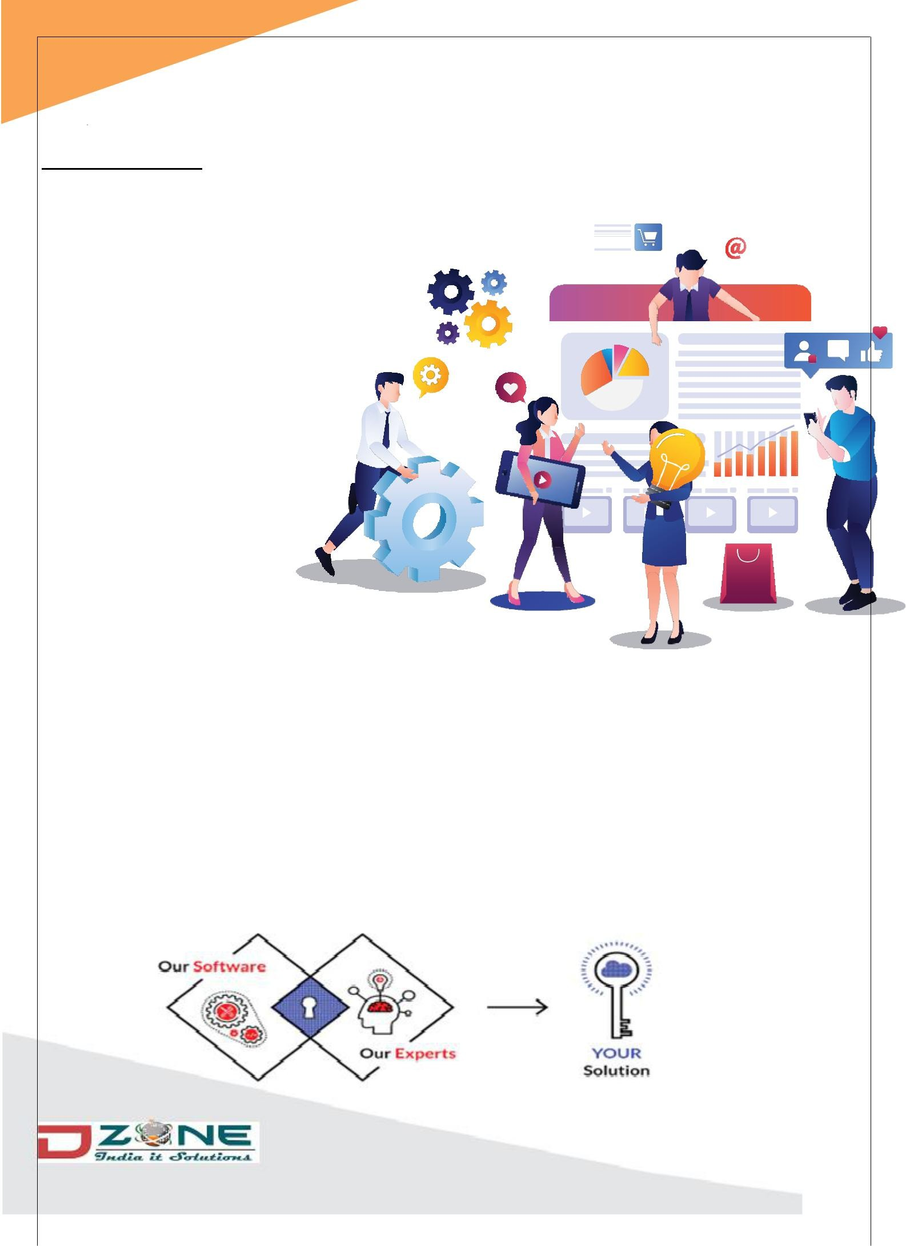**1**

**WHO WE ARE**

Start Innovate - Dzone India IT Solutions is a custom software services firm based in Jaipur.

The company also has a strong presence in the Rajasthan region. We have extensive experience in many diverse areas of software development. Dzone India was

founded by a strong

Professional team which has emerged as a global leader in technical solutions, providing innovative and end-to-end business solutions to companies across the globe.

Our experienced staff of professionals has worked with

a wide array of platforms, languages, and tools in the course of our various projects.

We are a service based organization that provides cutting edge business and technology solutions to fortune 300+ companies, with continuous innovation and quality, delivered by domain and technology experts. We follow scientific effort estimation processes coupled with sound management practices.

# 2

**OUR VISION**

“Our vision is our commitment to provide you with world- class products and services that exceed your quality, value, and reliability expectations.”

**OUR MISSION**

“To provide pragmatic and cost-effective business consulting, IT-enabled services / solutions that deliver tangible results to our global customers.”

# 3

**PRICING METHOD**

Dzone India offers multiple pricing models to meet diverse needs of our clients. We offer the following models:

1. Time & Material
2. Fixed Price
3. Milestone based Price

#### Time & Material

In this model, the project pricing depends on the amount of time spent

and the resources deployed. This is normally useful for complex projects which are prone to specification and design changes at a high frequency.

#### Fixed Price

In this model, price and time is quoted after assessing the time and resources it

takes to deliver the project. This is normally useful when the scope and specifications for the projects are clear and pretty much frozen. Any requirement changes during the development will be planned for in terms of time and money.

#### Milestone based Price

This model is normally suited for clients, who are very apprehensive about a new vendor. This allows them to monitor the projects progress closely and pay according to deliveries made.

# 4

**OUR PROCESS**

# 5

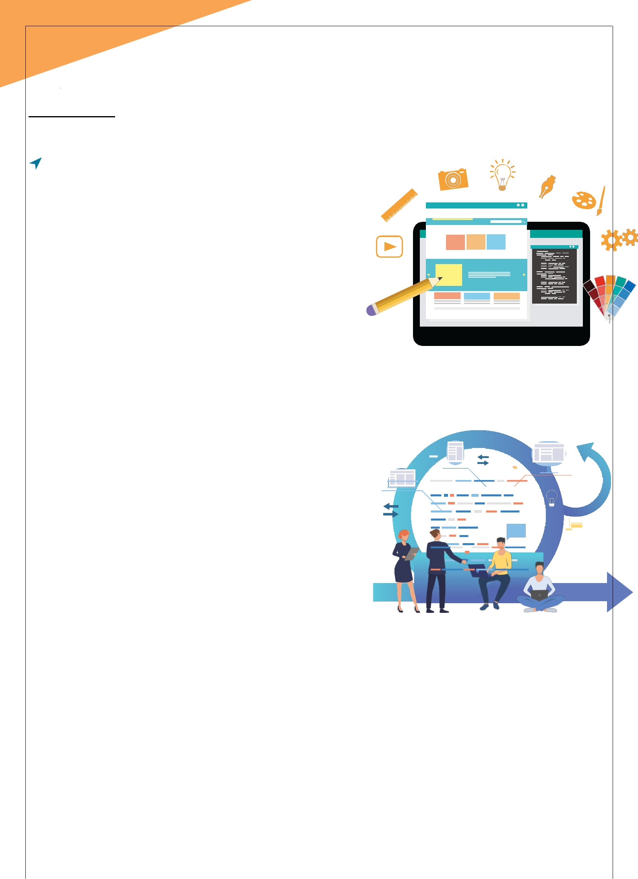

**SERVICES**

### Website Design and Development

We have the eye to create web designs that uniquely showcase your business to the world, since we strongly believe that a well-designed web site strongly contributes to the success of

a business idea. Our commitment doesn't stop with a functioning web site but also provide a whole range of related services for your online

business needs. We will ensure that you stand out and make your online presence felt in the web world.

### Custom Software Development

We have the experience and expertise in executing custom software development projects on a multitude of platforms and

software including PHP, JAVA and Dot net services,

Oracle, MS-SQL, Windows, Linux, Unix

and many others. Our goal is to provide high quality and cost effective business solutions and consulting services. Our business

delivery model significantly reduces software development cost by executing almost all phases of the software development offshore.

# 6

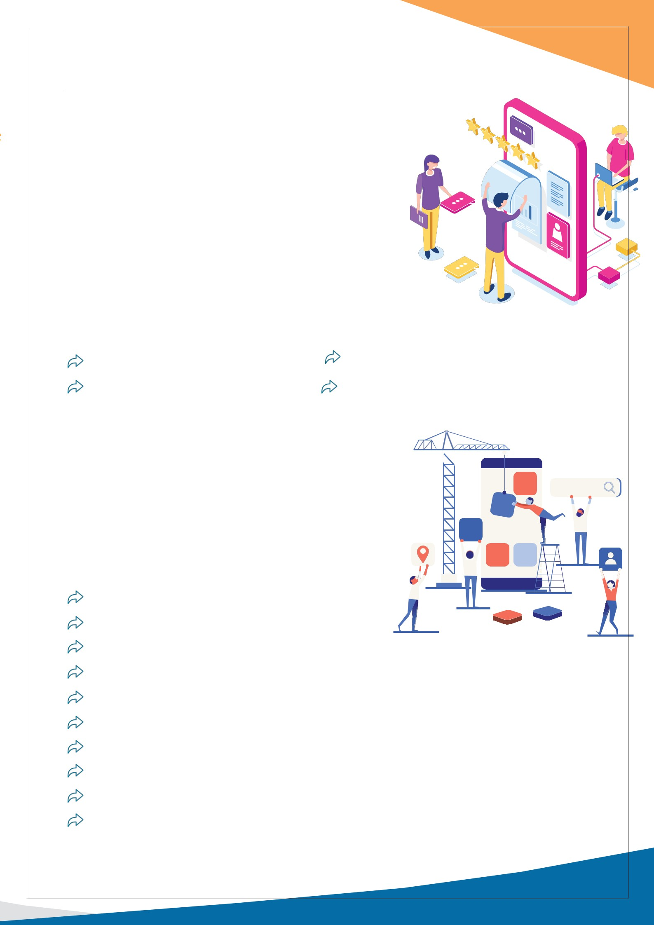

### Mobile Application Development

Dzone India offers a wide range of Innovative Mobile Application Development Services and Mobility Solutions across all major platforms like Ios and Android mobile devices. From product idea to end delivery, the mobile development expertise team at Dzone India, with their deep knowledge of the latest Mobile Application Development tools across all the mobile platforms delivers the best quality solutions that can add value to client’s business.

|  |  |
| --- | --- |
| IOS applications | Native apps |
| Android applications | Hybrid apps |

### Business Application Development

People and Companies these days looking for an overall solution that tend to deliver hyper connectivity,

real time modification and personalization. These aspects are forming the foundation for the new age business applications which are being developed.

Requests and Interpretations End to End solutions Complete automation

Cloud and desktop application development Inventory Software development e-Learning Software development Retail Management Systems

Customer Relationship Management Software Supply Chain Management Software Management Information Systems, and more

# 7

### Testing Services

We understand the significance of a good quality assurance process for creating world-class products. We have expertise in the development and execution of tests for applications in the client/ server, internet/web, and application space using both automated and manual technologies. We

undertake Functional testing, Automated regression, Compatibility testing, Performance testing, Black box testing and White box testing.

Functional Testing Performance Testing Compatibility Testing Security Testing

Test Advisory Services Web API Testing

### System Integration

Automation Testing Regression Testing Globalization Testing Mobile Testing Database testing

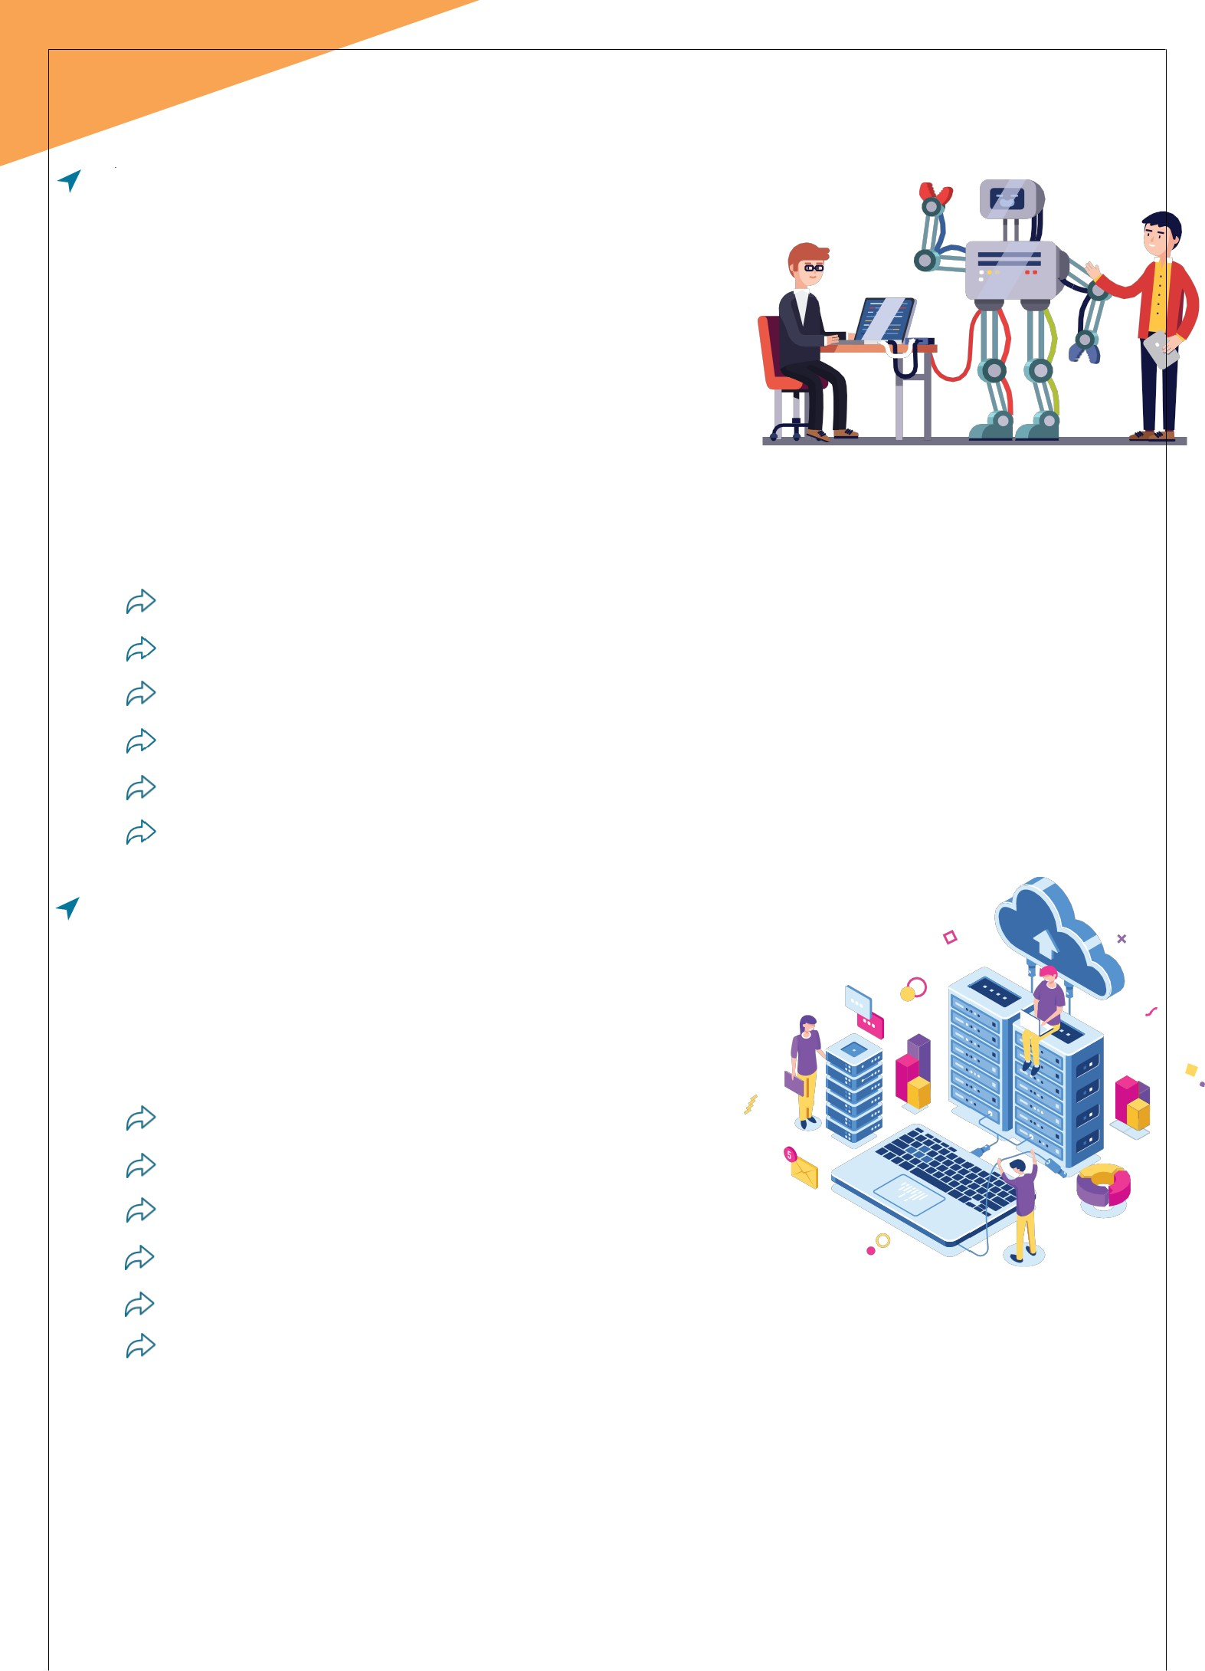

There are times when you might feel finding the right integration solutions partner can be difficult, but look no further, as Dzone India excels in doing just that.

Complete IT integration solutions CRM System

Inventory System Payment System Retail System

Travel Booking Script

# 8

rd

### 3 Party Integrations

Technology always tries to make things simpler and convenient, that is why we have software that are available which can be used as it is with some tweaking of course.

Third party integration is nothing much using this already available software scripts

into the applications as it helps save a lot of time, cost and effort.

Amazon API PayUmoney Gateway

Google API Stripe Payment

Zapier CCAvenue Gateway

MSG91 Gateway Skrill Gateway

Twilio Gateway Online Travel Agents

PayPal Network Payment Gateway

### Branding & Advertising

A brand is not what it says. It is what it conveys. Though communication seems easy to some, it's pretty complex in reality. To understand the personality, positioning & tone of a brand, and reflecting it across mediums is as art. From Print Ads to Menus, from Brochure design to Logos & stationery, our art reflects in everything we do.

**BRAND**

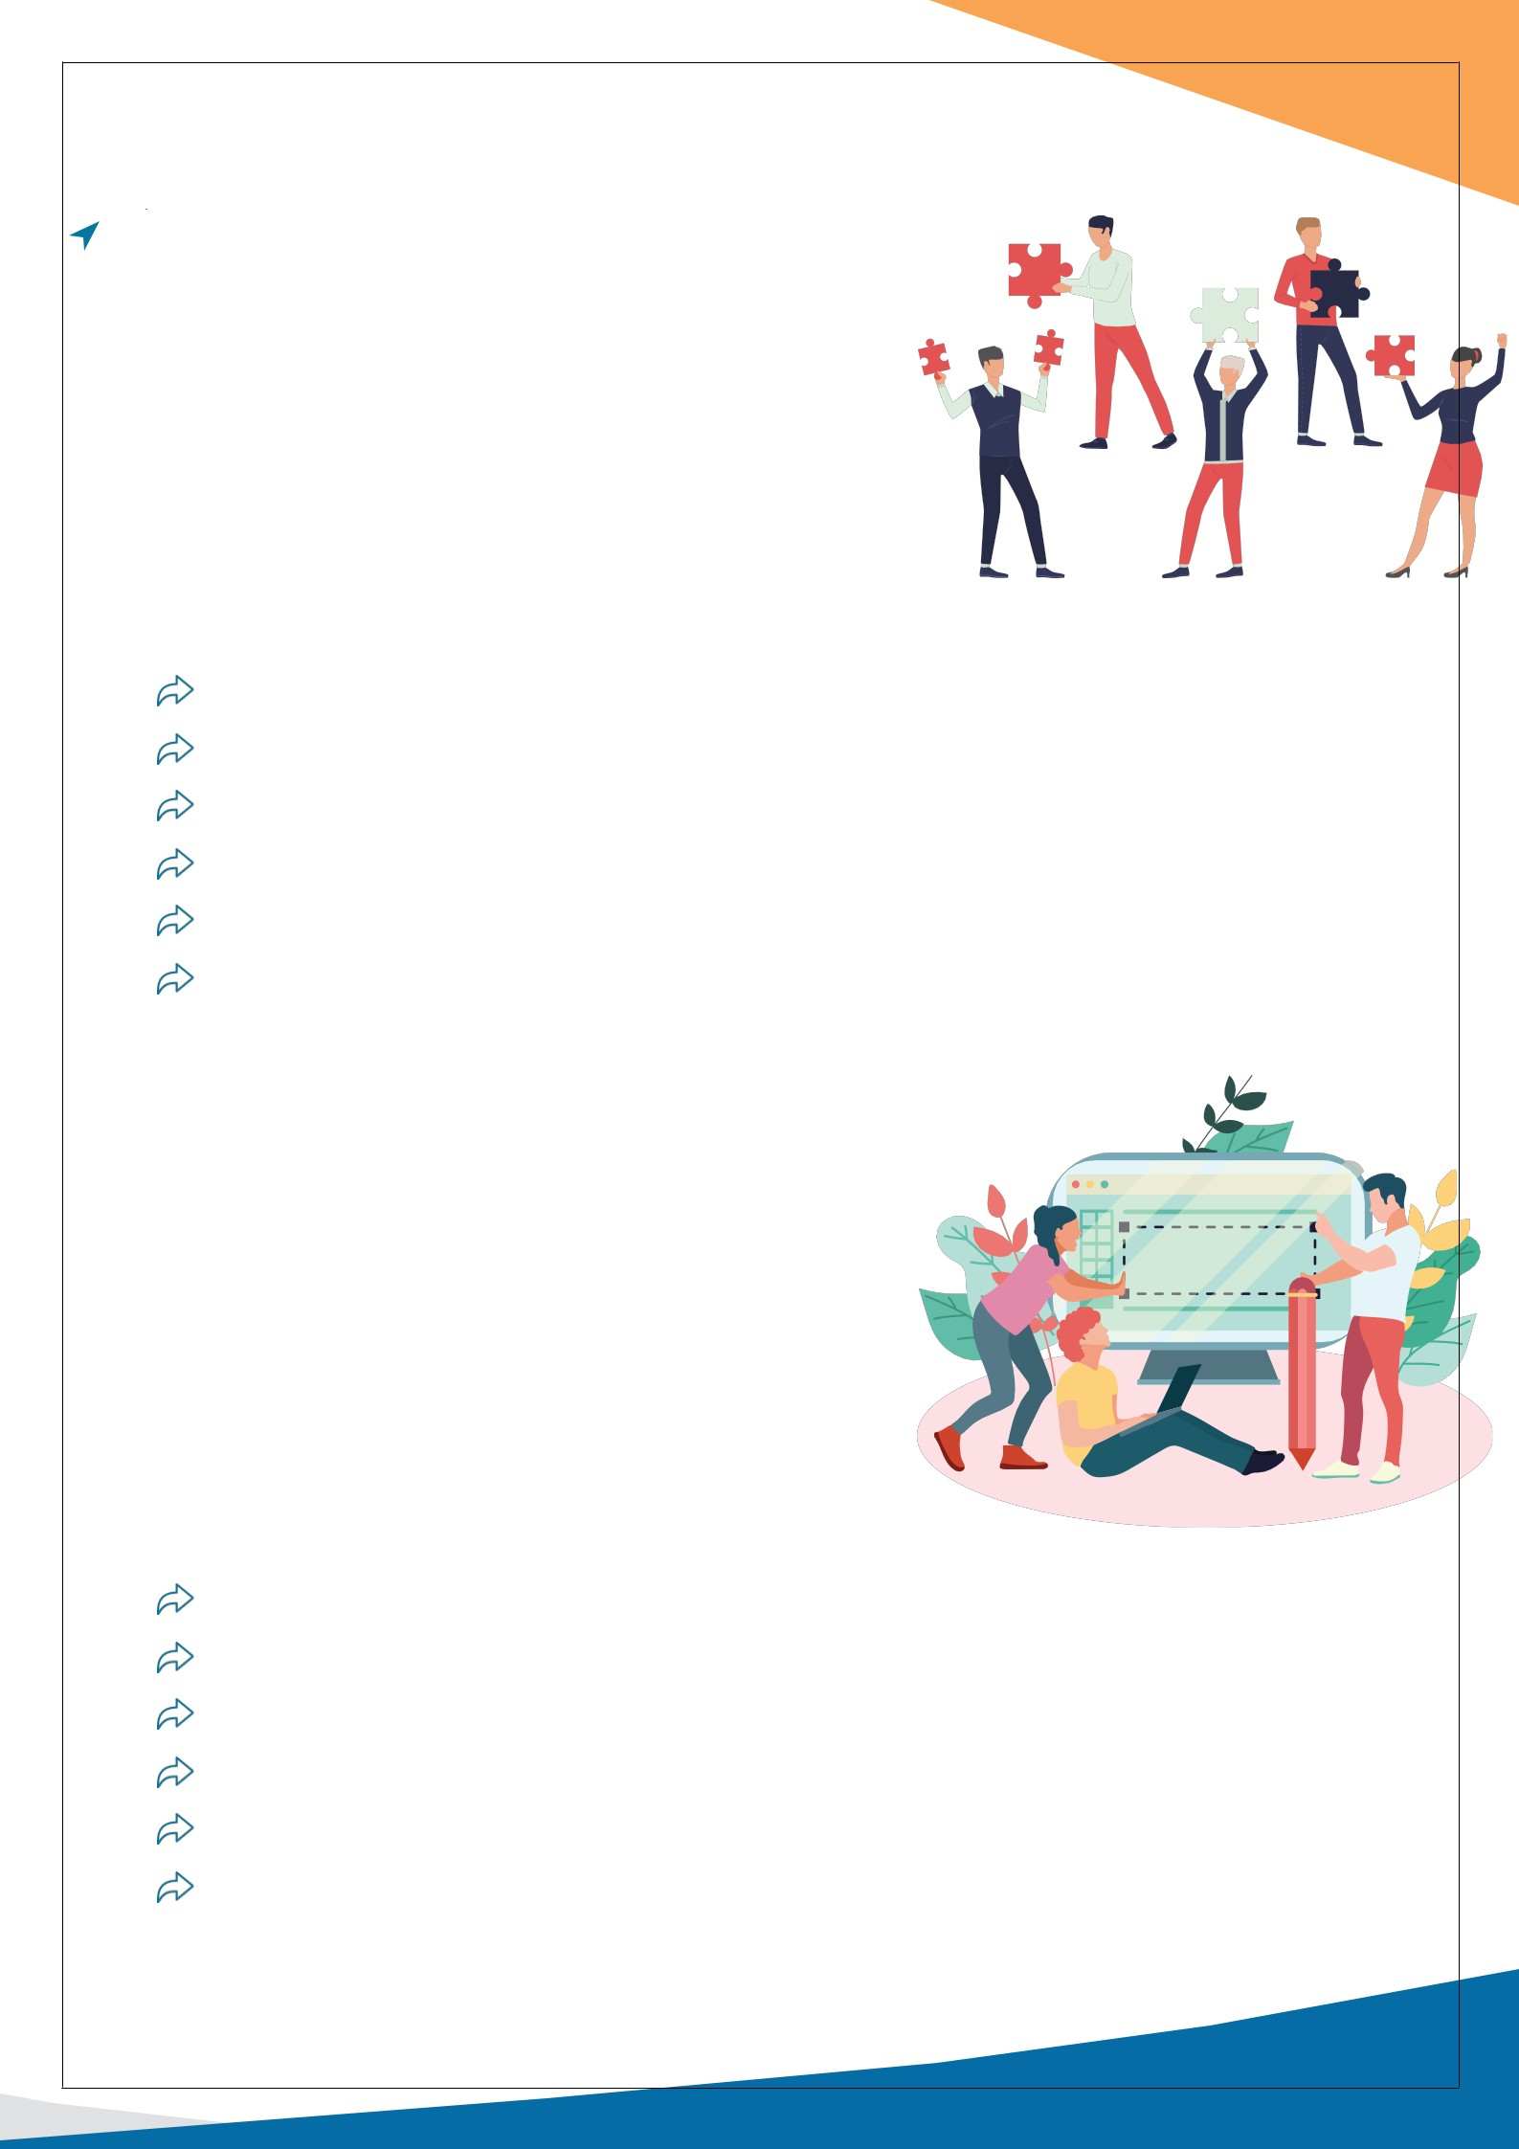

Facebook Marketing SEO

Instagram Marketing PPC

LinkedIn Marketing Email Marketing

Twitter Marketing Text Messaging

Affiliate Marketing Online Advertising

YouTube Marketing ORM Marketing

# 09

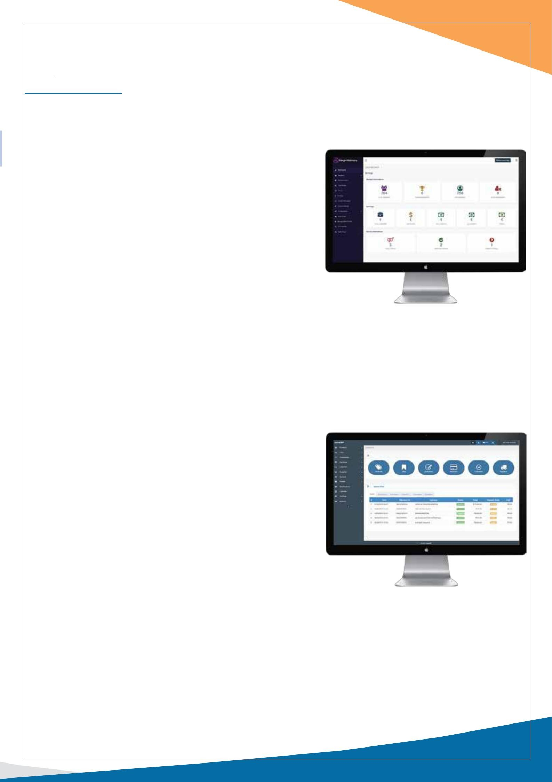

**OUR PRODUCTS**

### Matrimiyo

The Matrimiyo software is ideal software to start for next-generation online Matrimonial website or marketplaces. Our software is poised to start easy and grow faster on multiple revenue streams. Our Matrimonial script is created in PHP Laravel/MySQL, It runs on regular hosting available.

Our script can be easily be customized as per the requirement

of the industry or business niche. Script has revenue earning options like banners, packages, subscription-based module, premium verification seal & more.

Our Matrimonial Software for Website comes with one year support & free installation, We also provide customization services for PHP Matrimonial Software.

### ERP

ERP software is a business management technology solution that businesses and manufacturers use to collect, store, manage, and communicate data across all functions of the enterprise. Users interact with the software via visually collaborate dashboards. Typically ERP dashboards contain color-coded bar charts and graphs, along

with other visual descriptions of data that give users a fast

look at key metrics. It is crucial that ERP users have access to dashboard metrics because they track and measure data that leads to business process improvement. CRM systems help you to track and evaluate all business activities across the entire company.

# 10

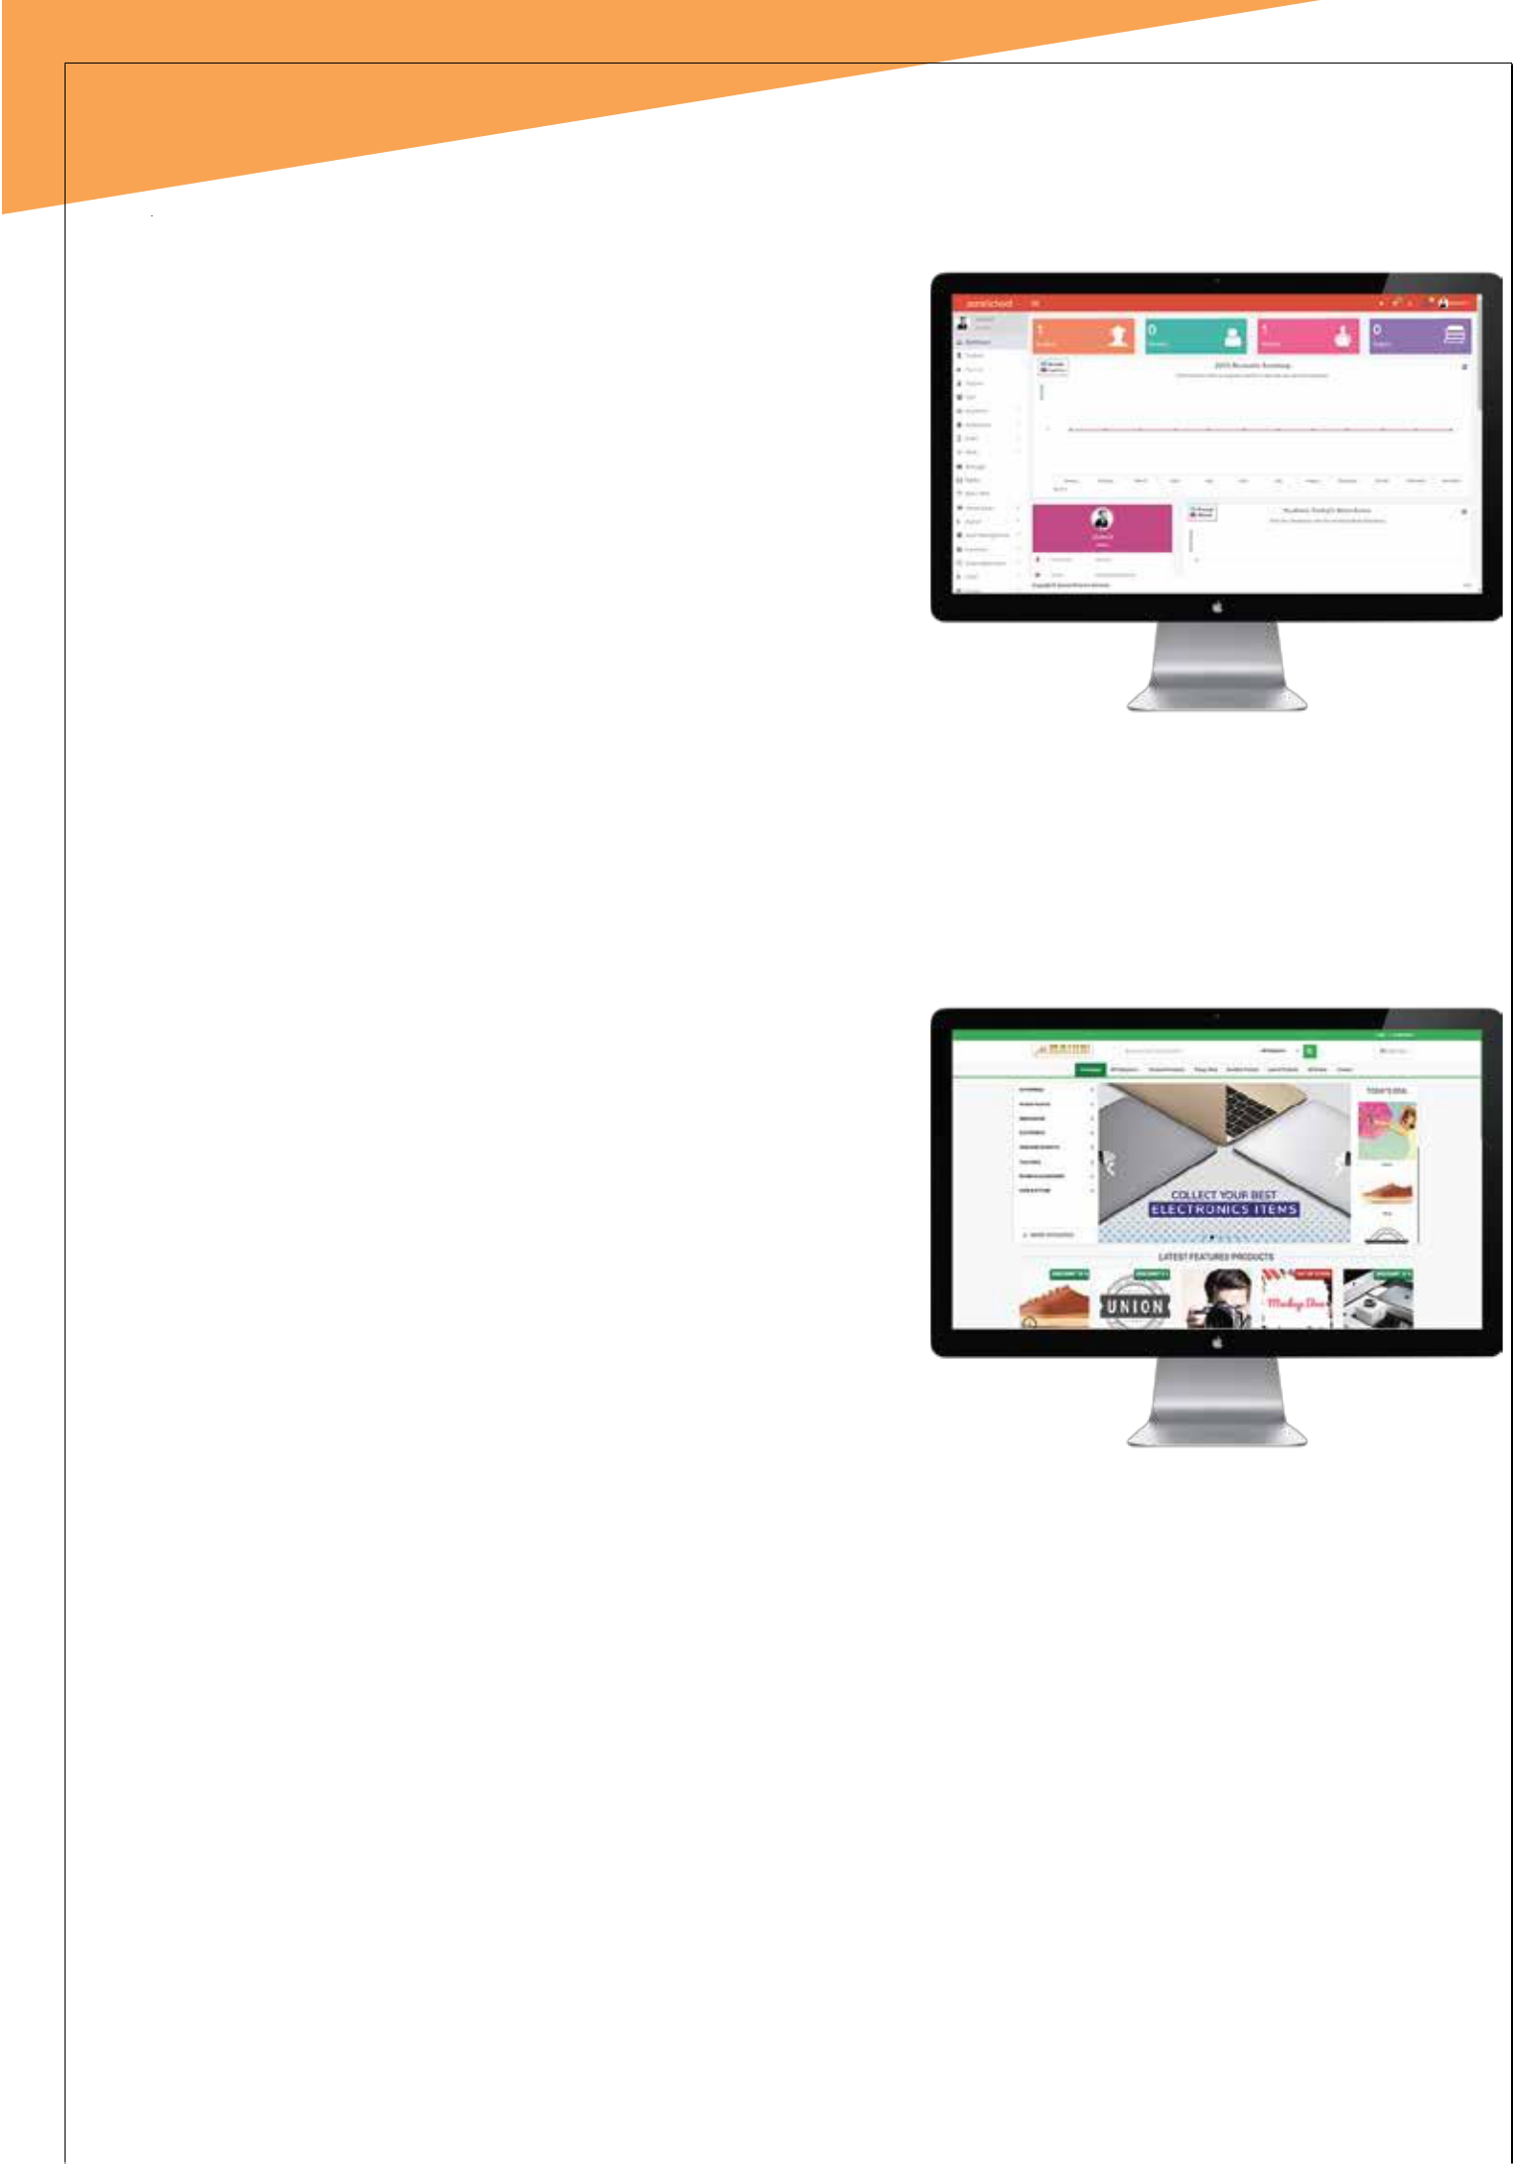

### School Management

School management is a Complete package for school/Institute Management System that helps to increase efficiency and decrease Paper-work. It contains a user-friendly interface with easy navigation makes it easy to use for every-one. Its scalable architecture and security features allow you to create custom and define

their access to the specific content only. You don’t need any

server or any high configuration system for maintaining our software as this is a web/cloud- based system. Anyone with basic knowledge in a computer system can operate it without any technical skills.

### E-Commerce

At Dzone India, we tailor E-Commerce development services to all our customer segments E-Commerce startups, companies already established in the market and those going on. For some, our assistance will mean a power- full business launch with the right technology stack. For others – a possibility to give their business a fresh start by re- plat forming successfully or growing into an Dzone channel venture

# 11

**PORTFOLIO**

## Jharkhand Mahadev

### Jnit College Sitapura Vaishali Nagar Jaipur

Bellacasa Retail Fashion Jaipur

Dubai E Visa

Dubai



### Yuwam Education Jaipur

Vasvi By Pyramid

Jaipur

Kudoday Food Delivery Jaipur

**12**

Destine Furniture Sitapura

Deelux Cables Sitapura



New Choudhary School

Ideal Education Point Pratapnagar

Art Bank Gallery Mi Road

Nexia Impex Sitapura

Jaipur Kurti

Bais Godwn

Rastogi Furniture Jaipur

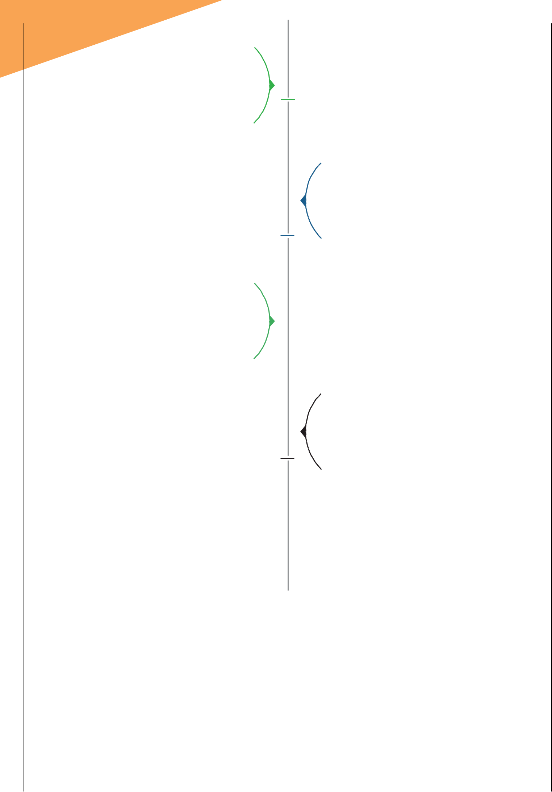**13**

**Global Art Export**

Sitapura

### Rawat Public School

Pratapnagar

women's hanger Mumbai

Kalila Fashion Delhi

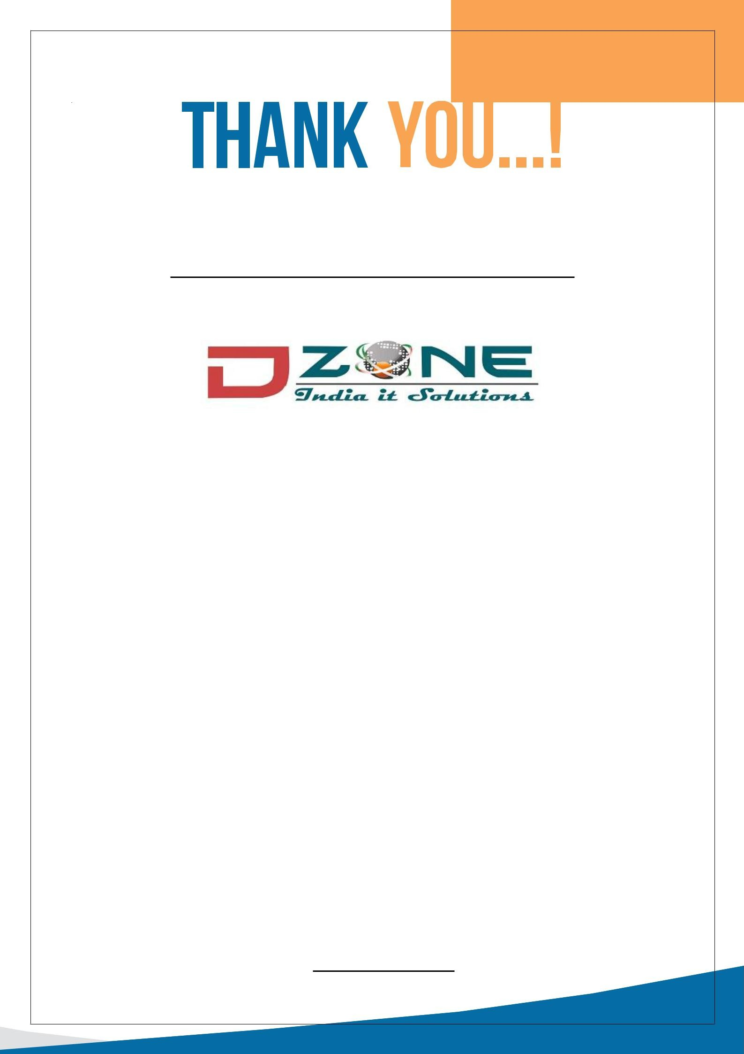**14**

For your precious time and attention

A Hub for Online Solution

Jaipur

110/42 ManglamTower Pratapnagar, 302033

Ph: +91 7014319191 | [sales@dzoneindia.org](mailto:sales@dzoneindia.org)